Experiment 3

Aim: To read an image in Python and convert the image to an outline using the Canny Edge Detection function in OpenCV.

Algorithm
- Import the OpenCV library.
- Read the input image.
- Convert the image into grayscale.
- Apply the Canny edge detection function.
- Display the original image and detected outline.
- Close all windows.

Program
import cv2
img = cv2.imread("image.jpg")
gray = cv2.cvtColor(img, cv2.COLOR_BGR2GRAY)
edges = cv2.Canny(gray, 100, 200)
cv2.imshow("Original Image", img)
cv2.imshow("Outline", edges)
cv2.waitKey(0)
cv2.destroyAllWindows()
Output
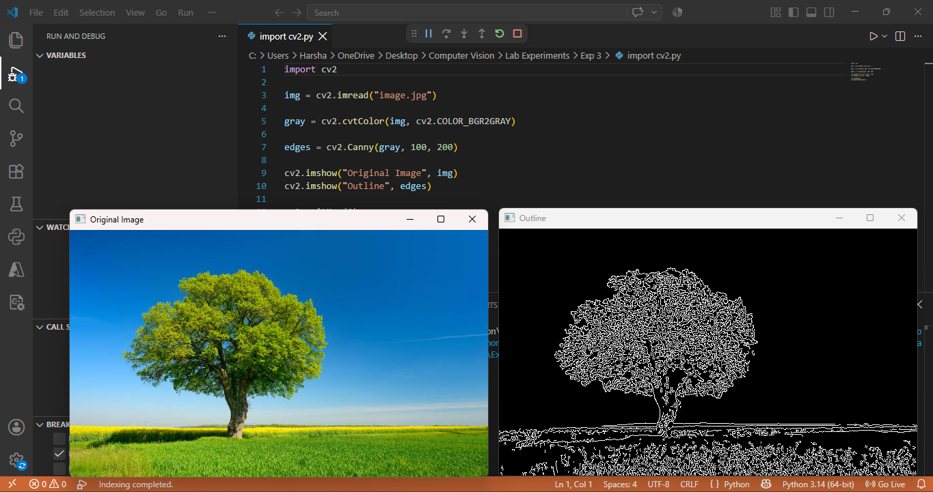

Result: Thus, the given image was successfully converted into an outline using the Canny edge detection technique.

